  Call for Papers  Editors  Tony Clark  tony.clark@tvu.ac.uk  Thames Valley University, UK  Jorn Bettin  jbe@sofismo.ch  Sofismo, Switzerland  Editors-in-Chief  Benoit Combemale  University of Rennes  Marsha Chechik  University of Toronto  Bernhard Rumpe  RWTH Aachen University  Important Dates  Intent to submit 01-Sep-2009  Paper submission 01-Nov-2009  Notification 18-Dec-2009 | 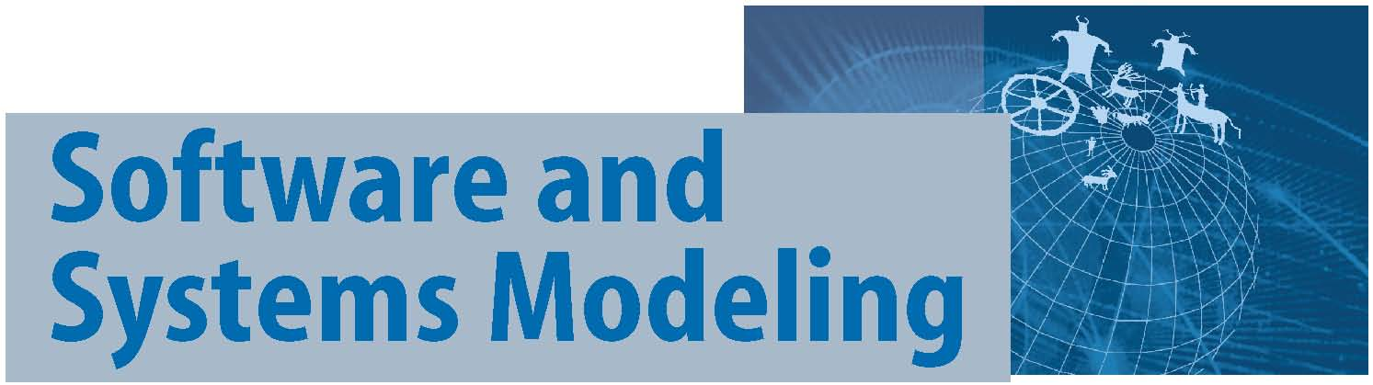  Theme Section:  Model-Based Interoperability  There is increasing interest in software tool chains and distributed systems that are based on modeling technology. Tool chains can be constructed by combining general purpose tools with domain specific tools. The challenge lies in identifying the ingredients needed to create highly automated software supply chains and systems that minimise the effort to integrate new suppliers of model based software artefacts. Meeting this challenge requires a significant increase in the use of formal (yet highly compact) specifications and advanced tooling for creating, managing, and exploiting shared formal models.  In recent years there has been a great deal of work addressing point solutions to model driven software engineering. In addition, techniques such as model based transformation, ontologies, and meta-modeling have matured to the point where they can be deployed on industrial-scale applications. Application of these techniques to the development of tool chains through model-based interoperability has not been addressed. The aim of this theme section is to provide a resource that describes the state-of-the-art in model based interoperability and to outline a roadmap that addresses the key challenges in this area.  The Journal of Software and Systems Modeling (SoSyM) invites original, high-quality submissions for its theme section on “Model-Based Interoperability” focusing on topics related to MBI, including:  - Requirements for interoperability: challenges and road-map; tool meta-models; architectures; requirements for modeling languages.  - Modularization of model-based artifacts: aspect-oriented models; best practices and challenges regarding granularity of models, model-based product lines, and versioning; distributed model supply chains; change impact analysis in large model-based systems.  - Technologies: use of existing technologies for interoperability; comparison of technologies; design of new technologies; analysis of current standards; proposals for extensions to standards.  - Experience reports: project organization; methodologies and guidelines for interoperability.
General Author Information | - Papers must be written in a scientifically rigorous manner with adequate references to related work.  - Submitted papers must not be simultaneously submitted in an extended form or in a shortened form to other journals or conferences. It is however possible to submit extended versions of previously published work if less than 75% of the content already appeared in a non-journal publication, or less than 40% in a journal publication. Please see the SoSyM Policy Statement on Plagiarism for further conditions.  - Submitted papers do not need to adhere to a particular format or page limit. Please consult the SoSyM author information for submitting papers for more details.  - Each paper will be reviewed by at least three reviewers.
Making a submission | - Communicate your intent to submit a paper by emailing the theme section editors the following information before the Intent to Submit deadline:  Title, Authors, and an Abstract.  - Possible submission formats are:  - Word (.doc, without macros)  - Rich Text Format (.rtf)  - PostScript (.ps, special fonts must be embedded)  - PDF (saved as readable in version 5.0 or earlier)  - Submit your work using the online submission system manuscript central:  - In step 1, select “Theme Section Paper” as the manuscript type.  - In step 5, make sure field “Cover Letter” includes the line: “Submission for Theme Section on Model-Driven Engineering for Security and Adaptability in Intelligent Systems”.
Further information | If you have any questions or require additional information about this theme section, please contact the editors.

